MONMOUTH COUNTY
PROSECUTOR’S OFFICE
Raymond S. Santiago
Monmouth County Prosecutor

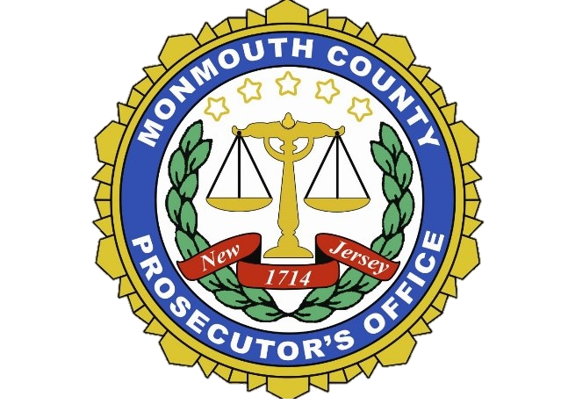
U VISA

What is the role of a certifying agency in the U visa application?
Many law enforcement agencies, prosecutors, judges and other certifying agencies are helpful in signing a U Visa certification and want to help victims.
In compliance with the Attorney General Law Enforcement Directive No. 2018-6, the Monmouth County Prosecutor’s Office has formalized procedures concerning the receiving and processing of requests for U Nonimmigrant Status Certifications from victims of qualifying crimes.
MCPO Procedure:
Upon receipt of a request for a U-Visa Nonimmigrant Status Certification (USCIS Form I-918 Supplement B), the request (and case file) will be forwarded to the Assistant Prosecutor who is/was assigned to the case involving the requesting victim or family member, for review and response.
The Assistant Prosecutor will review the USCIS Form, and any other additional documents provided by the requestor. It must be confirmed that the applicant was a direct or indirect victim of a qualifying criminal activity and suffered substantial physical or mental abuse. If there are any known errors in the form, it will be returned to the sender for correction.
Upon completion of the review of the case file, and any other documents provided, the Assistant Prosecutor will determine if the necessary criteria for the request for the visa certification have been met by the requestor. If approval appears to be justified, the form and attachments will be forwarded to the First Assistant Prosecutor for final review and certification if appropriate. The applicant will receive one original in a signed, sealed envelope, along with a courtesy copy of the I-918 Supplement B form. Do not open the sealed envelope as it should be sent directly to USCIS by the applicant. The review process should be completed within 60 days of the receipt of a request for a U certification, with the documents returned to the requestor.
- Please Note that once Certification Form has been signed, it is only valid for 180 days, from the date of signature.
Victims of Criminal Activity: U Nonimmigrant Status
The U nonimmigrant status (U visa) is set aside for victims of certain crimes who have suffered substantial mental or physical abuse and are helpful to law enforcement or government officials in the investigation or prosecution of criminal activity. Congress created the U nonimmigrant visa with the passage of the Victims of Trafficking and Violence Protection Act (including the Battered Immigrant Women’s Protection Act) in October 2000. The legislation was intended to strengthen the ability of law enforcement agencies to investigate and prosecute cases of domestic violence, sexual assault, trafficking of noncitizens and other crimes, while also protecting victims of crimes who have suffered substantial mental or physical abuse due to the crime and are willing to help law enforcement authorities in the investigation or prosecution of the criminal activity. The legislation also helps law enforcement agencies to better serve victims of crimes and promotes stronger community relationships.

U Non-immigrant Law Enforcement Certification Eligibility
You may be eligible for a U non-immigrant visa if:
* You are the direct/indirect victim of qualifying criminal activity.
* You have suffered substantial physical or mental abuse as a result of having been a victim of criminal activity / activities.
* You have information about the criminal activity. If you are under the age of 16 or unable to provide information due to a disability, a parent, guardian, or friend may present the information about the crime on your behalf.
* You were helpful, are helpful, or are likely to be helpful to law enforcement in the investigation or prosecution of the crime. If you are under the age of 16 or unable to provide information due to a disability, a parent, guardian, or friend may assist law enforcement on your behalf.
* The crime occurred in the United States or violated U.S. laws.
Victims are not required to have legal status in the U.S.A.

Determining Qualifying Criminal Activities
Abduction
Blackmail
Domestic Violence
Extortion
False Imprisonment
Female Genital Mutilation
Felonious Assault
Fraud in Foreign Labor Contracting
Being Held Hostage
Incest
Sexual Assault/ Abusive Sexual Contact/Sexual Exploitation
Slave Trade/ Peonage
Stalking
Torture
Trafficking
Witness Tampering
Unlawful Criminal Restraint
Manslaughter/ Murder /Prostitution
Kidnapping / Involuntary Servitude
Other Related Crimes*†
*Includes any similar activity where the elements of the crime are substantially similar.
†Also includes attempt, conspiracy, or solicitation to commit any of the above and other related crimes.
Filing for Qualifying Family Members
Certain qualifying family members are eligible for a derivative U visa based on their relationship to you the victim, also known as the principal, filing for the U visa. The principal petitioner must have their petition for a U visa approved before their family members can be eligible for their own derivative U visa, but all application may be submitted simultaneously.

If you, the principal, are... Then...
Under 21 years of age You may petition on behalf of your spouse, children, parents and unmarried siblings under age 18
21 years of age or older You may petition on behalf of your spouse and children only.

U VISA INFORMATION FOR LAW ENFORCEMENT
- Why is the U Visa Important?
- Strengthens law enforcement’s
ability to detect, investigate, and
prosecute crimes.
- Offers protections to noncitizen
victims of qualifying crimes in
keeping with U.S. humanitarian
interests
- What does a U visa provide? *

- Temporary Employment Authorization Document (EAD) also known as a “work permit” upon finding
by USCIS of prima facie case while the U-Visa decision is pending.

- Upon approval of the U-Visa by USCIS, the applicant and any derivative beneficiaries can obtain an EAD for a period of four (4) years.

- Eligibility to apply to USCIS for Legal Permanent Residence after 3 Years of approved U-Visa status. This would include all eligible family members who obtained a U Visa.
- Only USCIS decides whether to grant/deny an application for Employment Authorization Document and /or Legal Permanent Residence.
- You have the ability to withdraw your certification if a victim becomes un-cooperative after signing the certification form, or if misuse or fraud are detected. Just email LawEnforcement_UTVAWA.VSC@uscis.dhs.gov
Future Requests
If the Monmouth County Prosecutor’s Office signed a U Visa certification form, the victim may request a re-certification be signed for future use, such as an application to become a lawful permanent resident (i.e., “green card” application) or to renew a U-Visa status.
The victim’s qualifying family members may be eligible to apply to USCIS for Legal Permanent Residence as well. The victim must demonstrate that he or she did not unreasonably refuse to comply with requests for assistance in the investigation or prosecution since getting a U visa.
Again, law enforcement, prosecutors, judges, and other certifying agencies always have the option to withdraw the certification should a victim fail to cooperate, suspects fraud, or misuse of the certification.

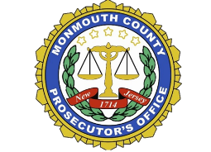
CONTACT US
732 431 7160
132 Jerseyville Avenue
Freehold, New Jersey 07728
visacert@mcponj.org
Download the MCPONJ Mobile app

