Police Department
Borough of Spring Lake Heights
555 Brighton Avenue
Spring Lake Heights, New Jersey 07762
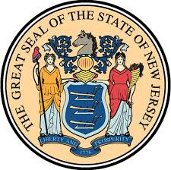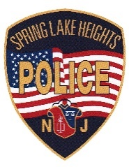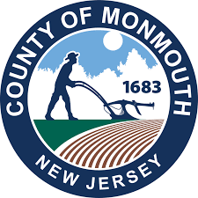
www.springlakehts.com
Telephone : (732) 449 – 6161
Fax : (732) 449 - 3047
Edward W. Gunnell
Chief of Police

Spring Lake Heights Police Department
Project Medicine Drop

Annual Unused Medication Collection & Destruction Totals
2021- 257 lbs.

2020 - 207 lbs.

2019 - 343 lbs.

2018 - 264 lbs.
2017 - 314 lbs.
2016 - 359 lbs.
2015 - 407 lbs.
2014 - 415 lbs.
2013 - 145 lbs.

